SOFTWARE TESTING METHODOLOGIES
Homework YARN

- Getting a remote computer running

Vagrant computer -
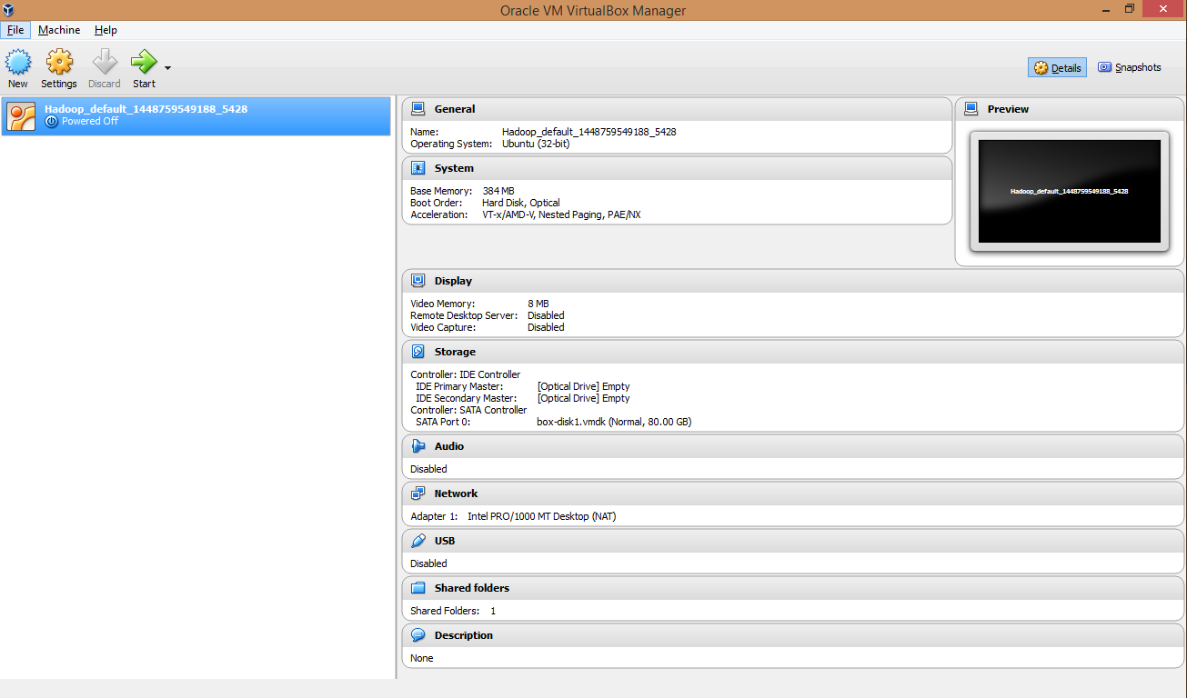

Registered for a Hacker account In PythonAnyWhere.com from which I will be getting SSH access.

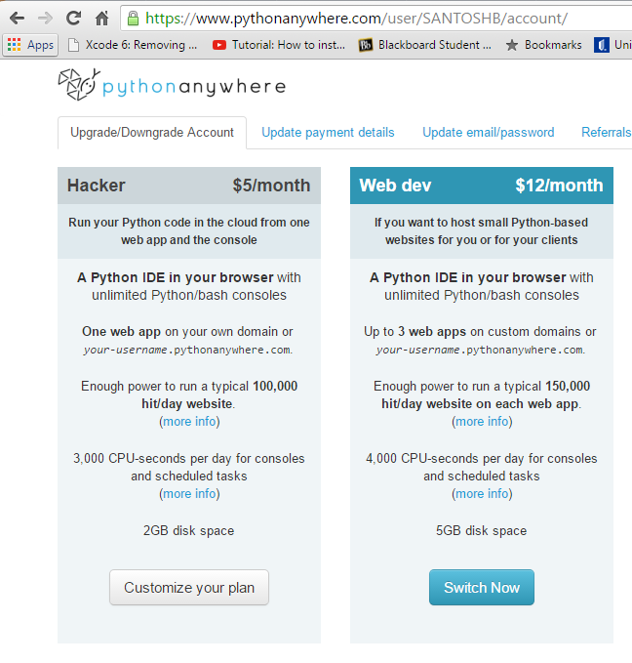

My ssh can be accessed through any command line in which ssh is installed properly with the following address of mine of PythonAnyWhere account
$ ssh SANTOSHB@ssh.pythonanywhere.com
Password will be the my PythonAnyWhere.com account in order to access the ssh through Vagrant

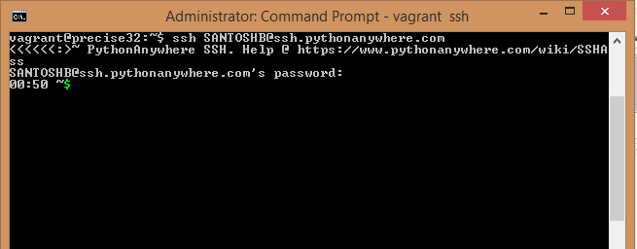
We can observe that my ssh of PythonAnyWhere.com has been successfully getting accessed through the vagrant box.

I’ve cloned git directories of https://github.com/gregdelozier/software_testing_class and https://github.com/Python-Yarn/Yarn/
We can observe the 2 directories in the below screenshot which is showing up ‘Yarn’ and ‘software_testing_class’
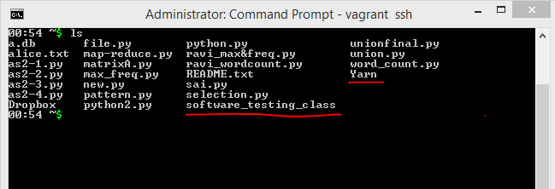

Editing the private.py in directory “software_testing_class >> lecture_9 >> private.py” with the user-name and password of my PythonAnyWhere account
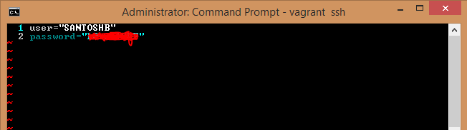

Remote_api.py, we have a file called remote_api.py.
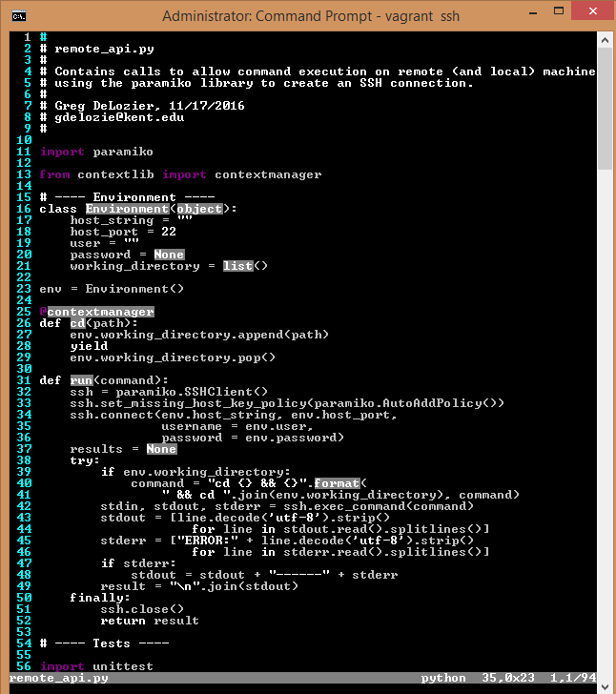
Running the remote_api.py
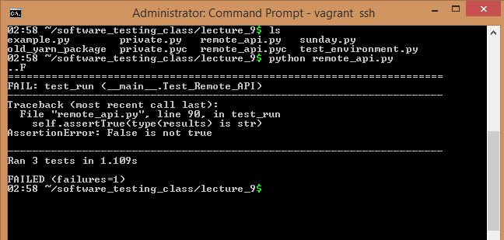

TEST CASE 1:
Running the sun.py using “vi version.py”.
This program will determine whether there is a python version of “3.4” in the PythonAnyWhere.com. If there is a python version of 3.4, then the test will pass with the time stamp. Otherwise, the test will be failed.

Code
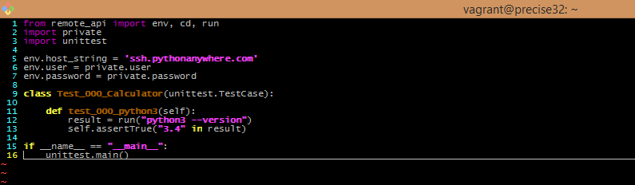

Output
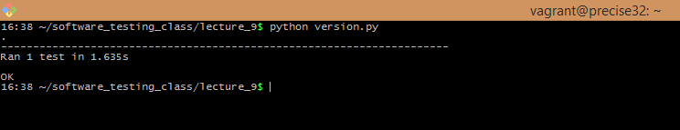

TEST CASE 2:
In this test case, we have written an automation case where it finds for “pip –version” to be installed of 7.1.2
If that version is installed, then the test case will pass or else the test will fail.
Code
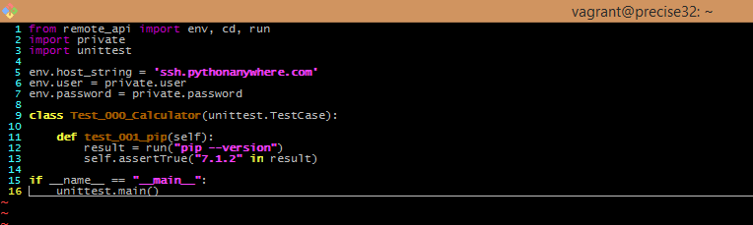

Output
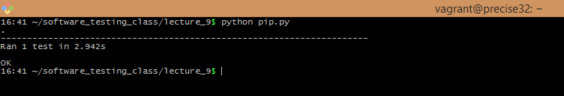

TEST CASE 3:
In this test case, I’ve written the test cases in such a way that the test case will find “Yarn” directory followed by its “yarn” sub-directory and then checks “tests” directory under the “yarn” for the files “test_env.py” and “yarnfile.py”
-- Yarn
-- yarn
--tests
-- test_env.py
--yarnfile.py
Code
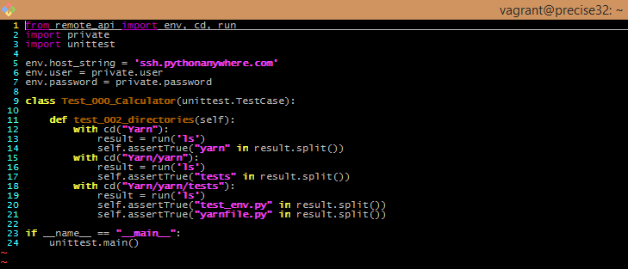

Output
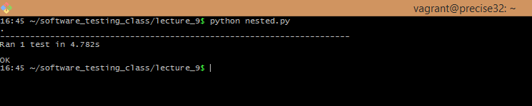

TEST CASE 4:
This test case will determine the permissions of the directory “software_testing_class”
Code
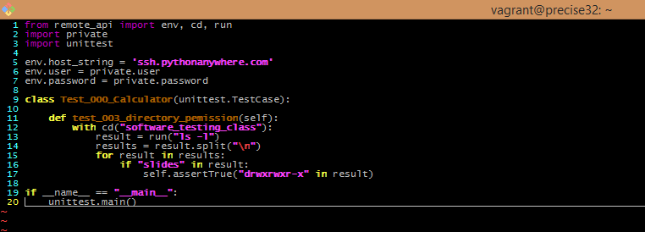

Output
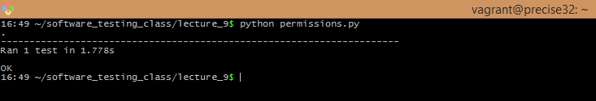

TEST CASE 5:
In this test case, the program will search for a text file “sample.txt”, then removes it from the directory and displaying all the files in that directory just to make sure.
Code
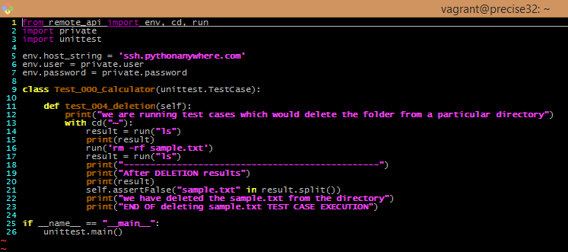
Output
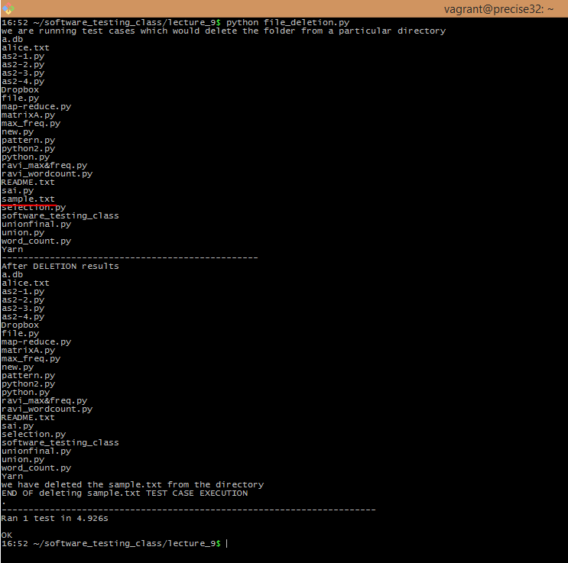
TEST CASE 6:
This test case will first create a directory “sbajjuri” and delete that directory “sbajjuri” again.
Code
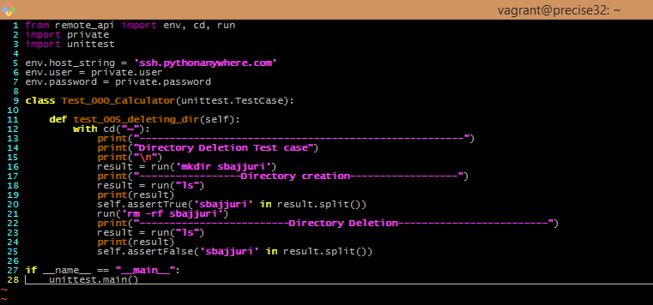
Output
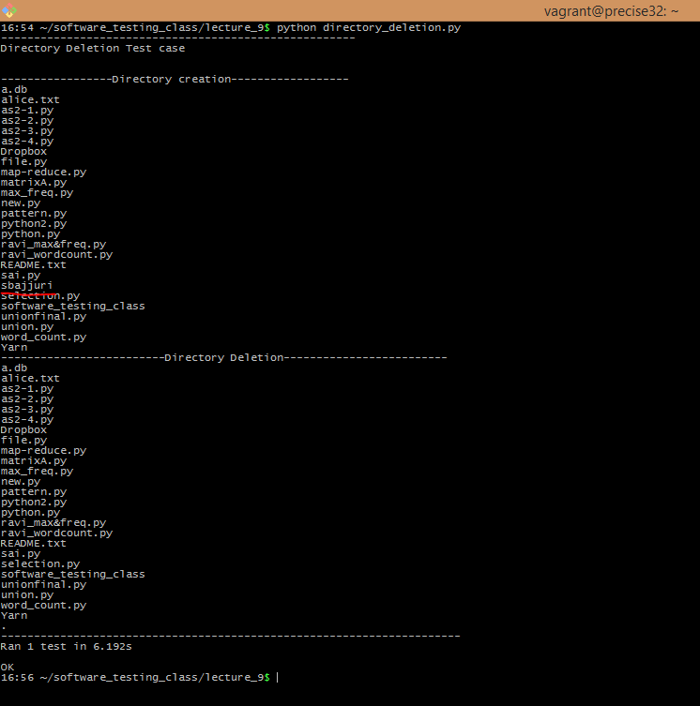
TEST CASE 7:
In this test case, we perform several operations here. They are:
- Make a directory (sbajjuri)
- Make a sub directory under the directory (sub)
- Create a text file in this sub directory (sbajjuri.txt)
- Getting the permissions of this sbajjuri.txt
- Changing the permissions of this text file

Code:
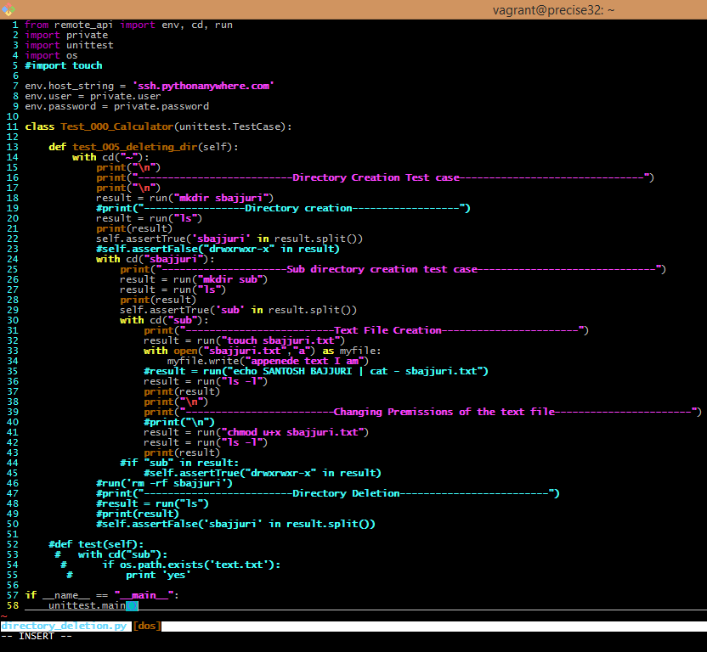
Output:
